# Programming Exercise

The purpose of the this task is to provide talking points for an interview, where the skill level is assessed. The interview will be on the method and understanding, and to a lesser extent on syntax and style.

It is expected that exercise should be solved within 2-4 hours.

## Domain

The problem domain is a FX Exchange, where an amount in one currency is exchanged to another amount in another currency. This is commonly done using an ISO currency pair, e.g. EUR/DKK, where EUR is the main currency and DKK is money currency. Each currency pair is associated with an exchange rate, where 1 of the main currency can be exchanged to given amount in the money currency. For instance: EUR/DKK 7,4394, would denote that 1 EUR can be exchange with 7,4394 DKK.

Task  
Using the exchange rates below, denoting the amount Danish kroner (DKK) required to purchase 100 in the mentioned currency, make a command line tool that is able to take a ISO currency pair and an amount, and write the exchanged amount to the console

| Currency | ISO | Amount |
| --- | --- | --- |
| Euro | EUR | 743,94 |
| Amerikanske dollar | USD | 663,11 |
| Britiske pund | GBP | 852,85 |
| Svenske kroner | SEK | 76,10 |
| Norske kroner | NOK | 78,40 |
| Schweiziske franc | CHF | 683,58 |
| Japanske yen | JPY | 5,9740 |

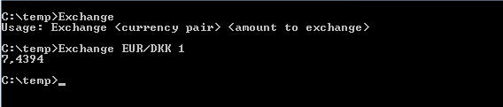

It is expected that a currency pair can contain any combination of the mentioned currencies (including DKK), e.g. EUR/USD. If a currency pair has the same ISO currency as both main and money, then the passed amount should be returned. If a currency pair contains an unknown currency, then an appropriate error message should be written to console.

It is expected that the code includes tests for the solution elements.

Please note, that the firewall will restrict executables to be sent via email. As such you should only send the source-code. We will build the application during the evaluation of your solution.

## Requirement

Please provide a solution in either C#

You may use any frameworks (testing, mocking etc.) as long as it is freeware and available for download from nuget.org or embedded in your solution.

Please don’t integrate with any kind of databases. Use of filesystem is ok, but you are welcome to hardcode the exchange rates supplied.